**Shell script for keycloak to create user attribute in keycloak using shell script**

1)Create two files

1. a) first is csv file for to fill user detail
2. b)second is sh file for script to add users attribute by calling csv file

Add these files in keycloak bin folder

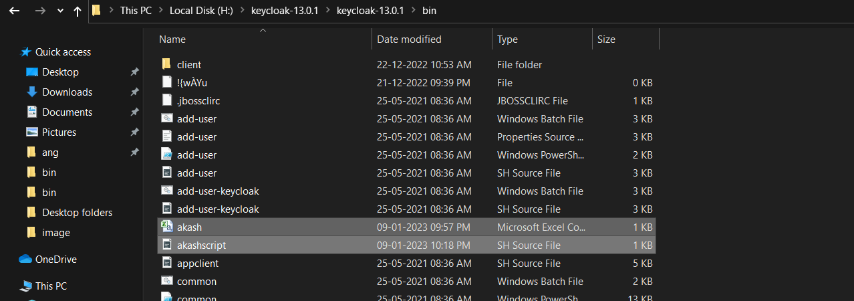

2) The csv file contain the below attributes,it is excel save as .csv

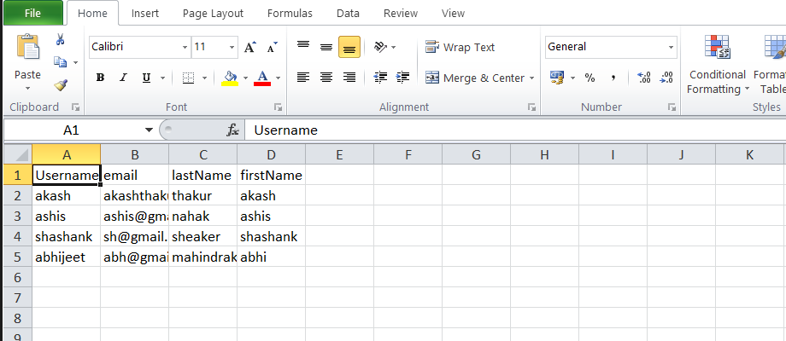

1. In sh file add the script as below shows

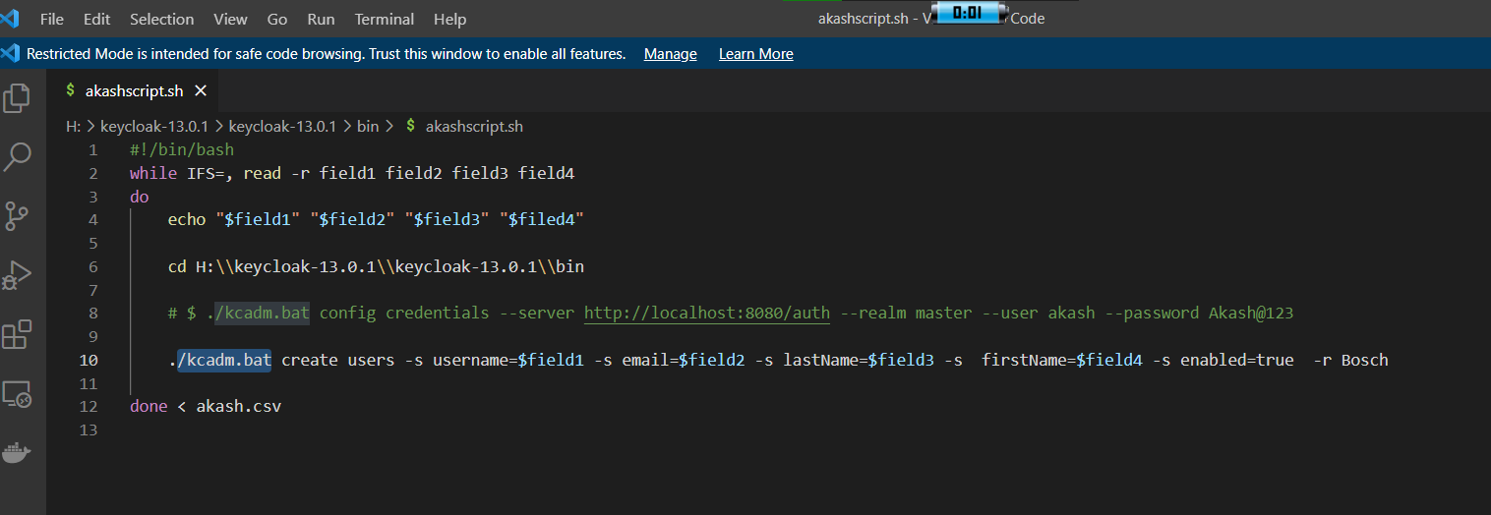

In this

While loop to read fields

Echo to print fields

Cd H:\\ is a path of keycloak bin folder

#$ ./Kcadm.bat for login keycloak --user akash for user name of keycloak and –psd for password for keycloak

./Kcadm.bat to create user attributes in keycloak the last –r Bosch is relm name

Done < akash.csv is a csv file to read and add those data fields to keycloak

This all data will be added in keycloak like

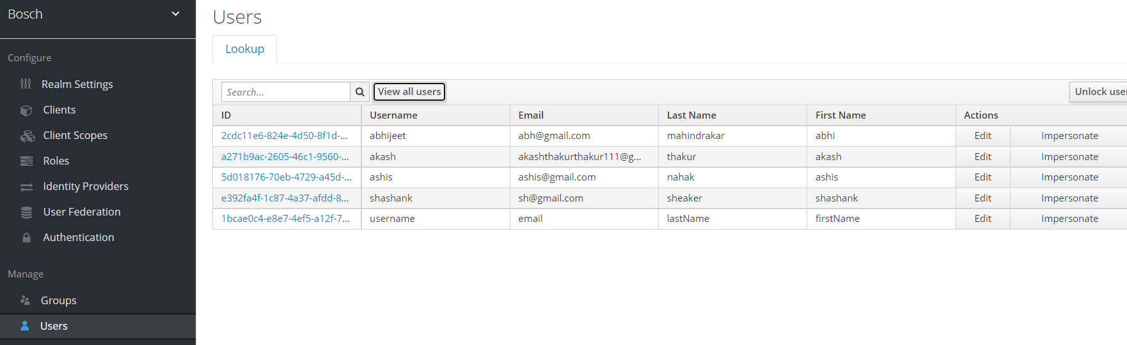

To add data by script

4 1)

Go to keycloak bin path and run as git bash like this

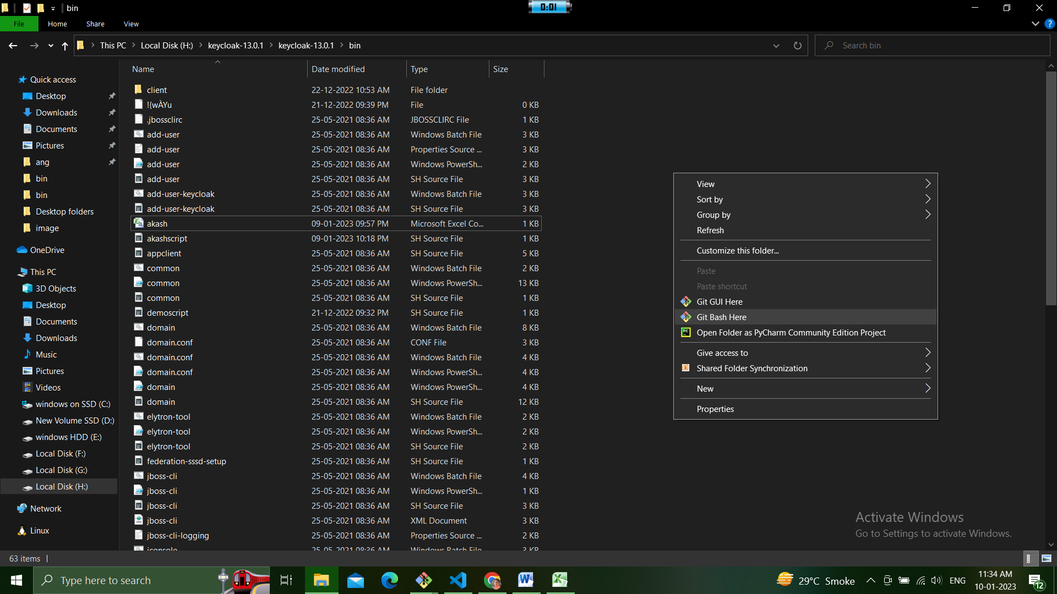

Once entered into git bash folder run keycloak by typing this command

1. $ ./standalone.bat

Bat for windows

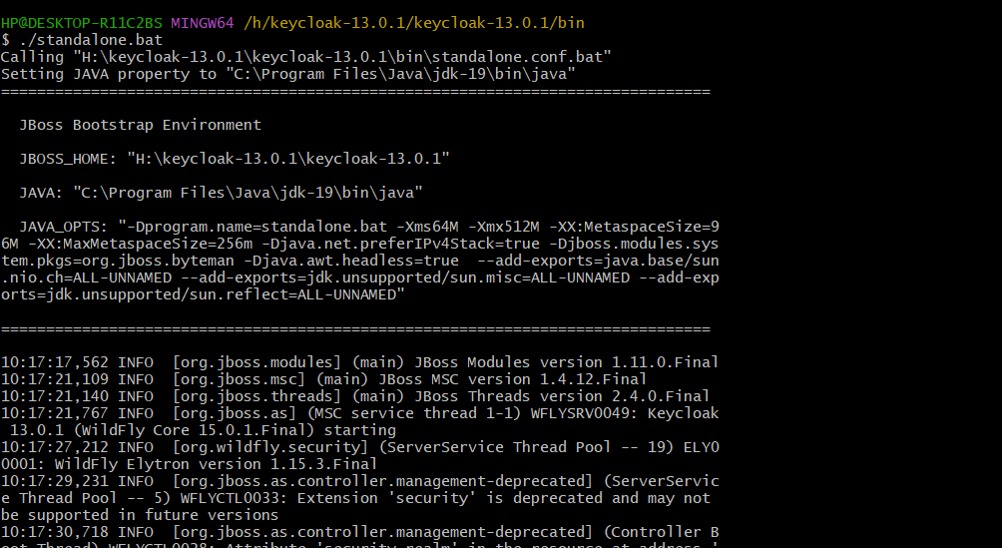

Run like this

1. One new gitbash terminal like this

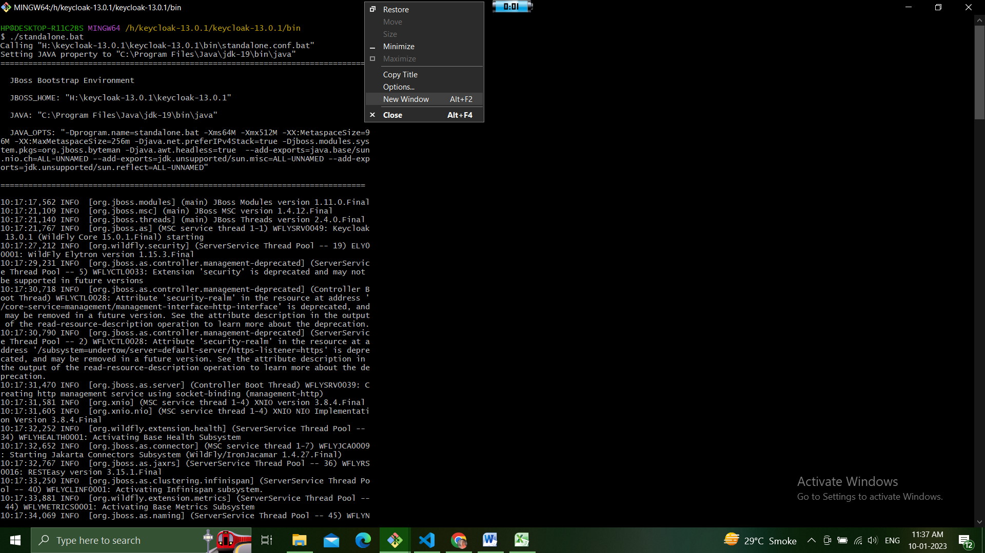

1. In this type this command first and then enter
2. Command below

./kcadm.bat config credentials --server http://localhost:8080/auth --realm master --user akash --password Akash@123

1. Second type this command for add script end then enter
2. ./akashscript.sh

This is a file name of our script file like this you do and enter

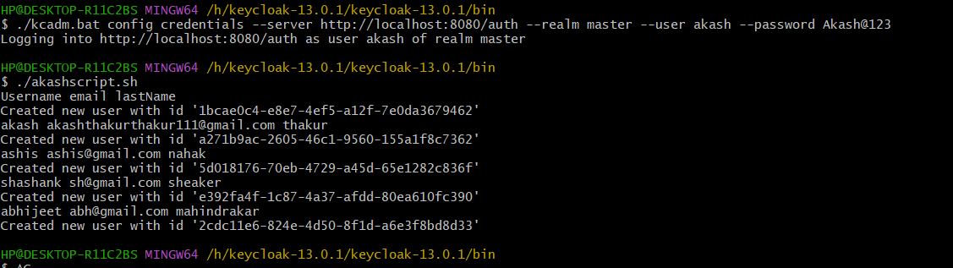

Now the your attribute added in keycloak successfully check in keycloak

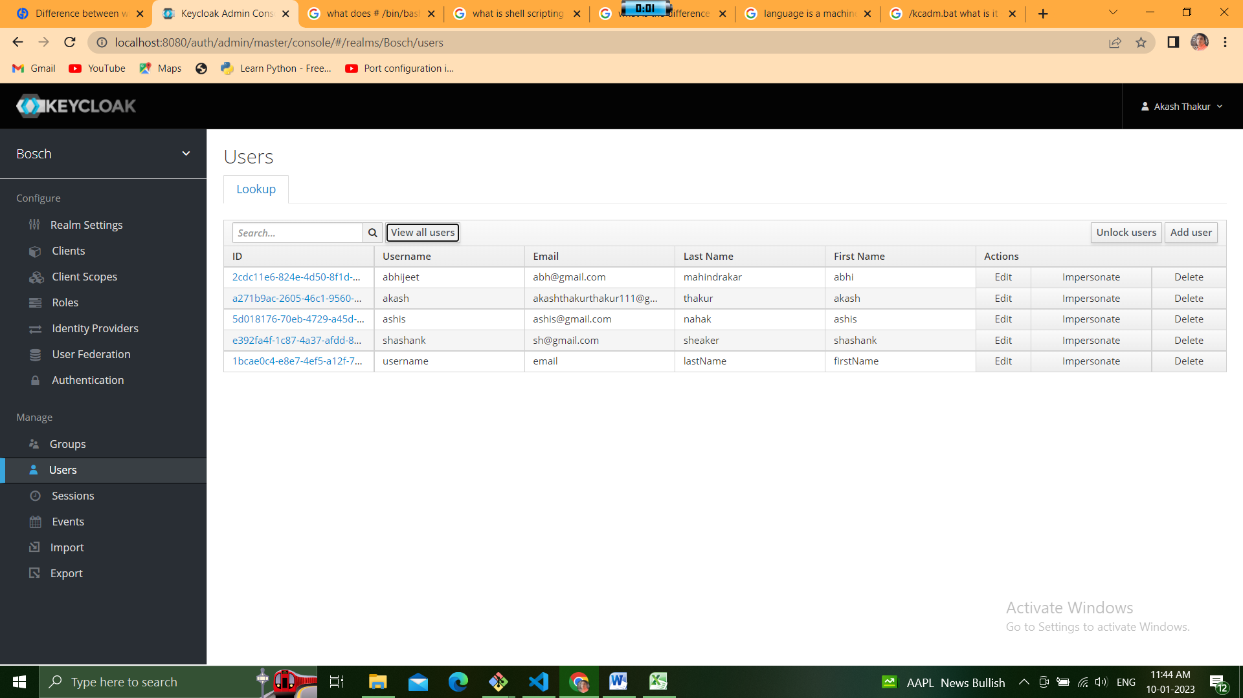

Now this script for keycloak to add attribute is done